COMPARISON OF THE INTROSORT
HYBRID SORTING ALGORITHM AND IT’S 3 SORTING ALGORITHIM COMPENENTS

INTRODUCTION

A sorting algorithm is a method that’s used for arranging elements of an array in a specific order such as sorting order of numerical elements in an ascending or descending order. Sorted data is easier for machines(computers) and human to read and analyse, it allows efficient generation of report and rankings. Many search algorithms (e.g. Binary search) require elements to sorted so that it will achieve maximum efficiency.

Hybrid Sort is a sorting algorithm that combines two or more simpler sorting algorithms to achieve better performance than any algorithm on its own.

IntroSort is a prime example of hybrid sort algorithm, its goal is to provide a consistently high performance, avoiding then worst-case scenarios of its component algorithms. It starts with Quick Sort, switches to Heap Sort when recursion depth exceeds a threshold and uses Insertion Sort for very small subarrays. It guarantees O (n log n) performance in the worst case while maintaining fast average performance.

Objectives of this experiment:
- It’s to compere the performance of insertion sort, Heap Sort, and Hybrid sort.
- Evaluate execution time, memory usage and stability for different input sizes and scenarios.
- Determine the most efficient sorting algorithm for practical applications.

Implementation Details

Sorting Logic
- Insertion Sort
It iterates through the array, inserting each element into its correct position in the sorted portion of the array.
It stary with the second element and considers it the key. Compares the key with every element on its left. It then shifts all larger elements one position to the right to make space and insert the key to its correct position and repeat for all remaining elements.

- Heap Sort
It builds a max leap and repeatedly extracts the maximum elements and rebuild heap, then place extracted elements at the end of array.

- Quick Sort (Median of Three)
It selects the pivot as the median of the first, middle, and the last elements. Rearrange array so elements smaller than pivot go left, larger go right. Recursively apply to the left and right partitions.

- Hybrid Sort (Quick + Insertion)
It uses Quick Sort to recursively partition the array. When the subarray becomes small it switches to insertion sort and leverages the strength of the algorithm.

Code Snippets

- Insertion Sort
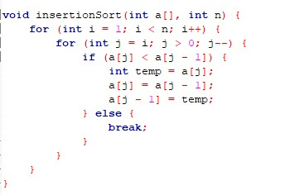
- Heapsort
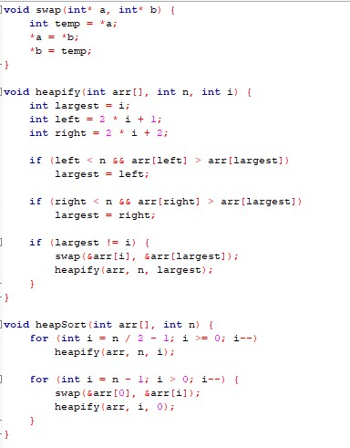

- Median-of-Three Quicksort
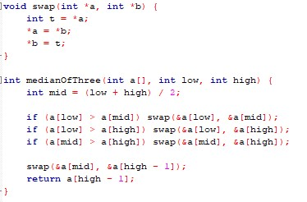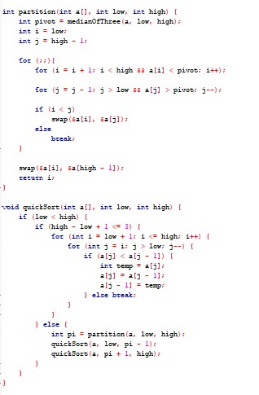

- Introsort (Hybrid)
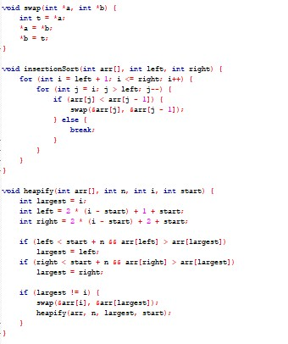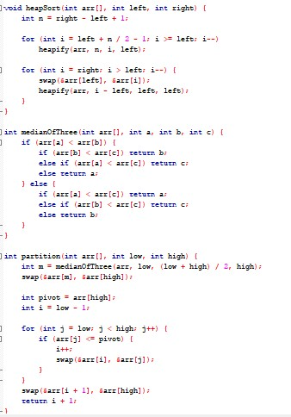

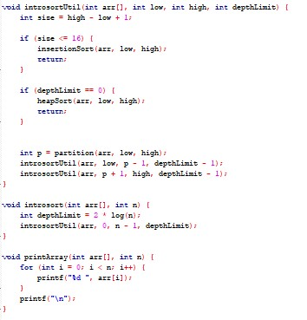

Optimisation Used
- Hybrid Sort uses threshold-based insertion for small partitions.
- Quick Sort uses median-of-three pivot selection.
- All sorts are in-place to minimize memory usage.

Experimental Setup

Test Environment
- CPU: Intel(R) Core (TM) i5-8265U CPU @ 1.60GHz (1.80 GHz)
- RAM: 8 GB
- OS: Windows 11 64-bit
- Compiler: Code Blocks
Datasets
- Random Array
Elements are generated randomly; it represents a real-world unsorted array. It tests average case performance.
- Sorted Array
The array is already sorted in ascending order; this helps to test best case performance for algorithms like insertion sort which is extremely fast on sorted array.
- Reverse Sorted Array
The array is sorted in a descending order; this test is the worstcase performance especially for insertion and quick sort with poor pivot selection
Input Sizes
Small Databases-it takes 10 to 1 000 elements
Medium Datasets-it takes 5 000 to 100 000 elements
Large Datasets-it takes 250 000 to 1 000 000 elements
For measurement it uses execution time using clock () in milliseconds

Results And Analysis
I ran my algorithm 5 times using random generated arrays, then I calculated the average execution time.
 | 1,000 elements | 10,000 elements | 100,000 elements
Insertion Sort | 1,6ms | 153ms | 9485,4ms
Heapsort | 0.2ms | 4ms | 42,2ms
Quicksort  (Median-ofThree) | 0ms | 2,2ms | 22,6ms
Introsort (Hybrid) | 0ms | 2ms | 22,2ms

Graph
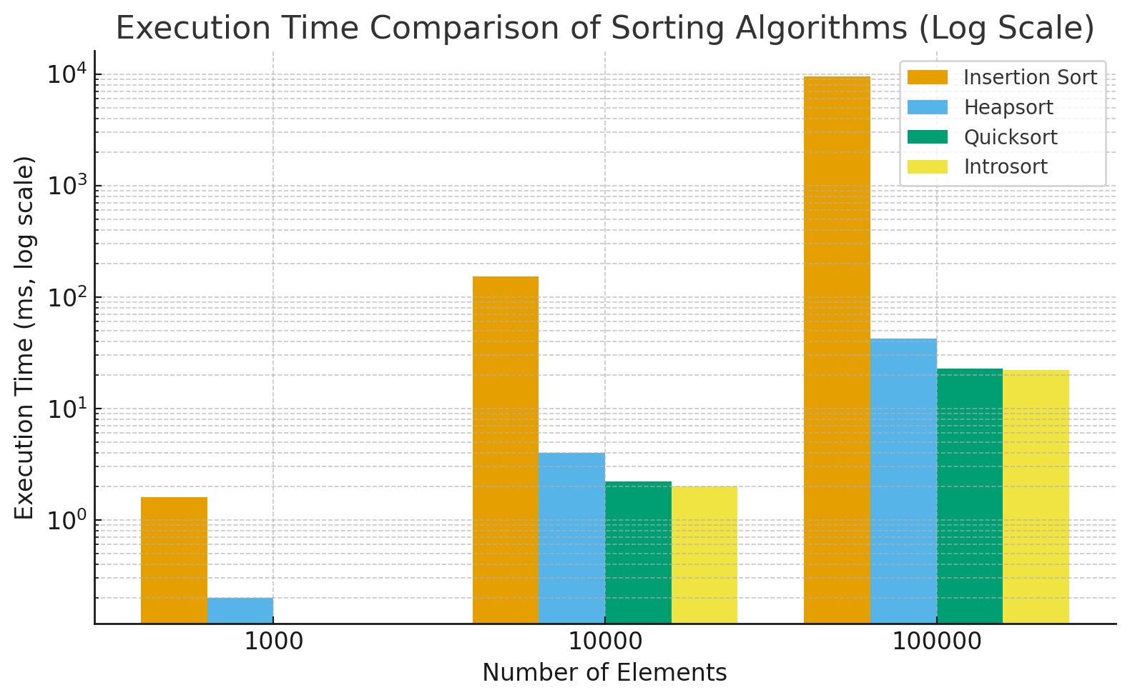

Observation
- Insertion Sort works well for small arrays because as array size increases time taken to execute also increases, it has a computational complexity of 𝑂(𝑛²)
- Heapsort has a good performance across all array sizes with a computational complexity of 𝑂(𝑛 log (𝑛)
- Median-of-Three sort works better than insertion and heapsort for most cases, this sort reduces risk of worst-case performance.
- Hybrid sort it has a constant performance that’s faster than of Median-ofThree sort in large arrays. This ensures the best overall efficiency and 𝑂(𝑛 log(𝑛)) worst-case guarantee.

Discussion
Introsort shows the best efficiency all-around performance since it combines the quicksort speeds and heapsort worst case safety. Insertion sort becomes impractical beyond 10,000 elements while quicksort remains efficient. Only the Insertion sort is stable all the others are not stable.

Conclusion
In conclusion Introsort is the most efficient and reliable algorithm. It achieves fast average performance like Quicksort and guarantees 𝑂(𝑛 log(𝑛)) behaviour in all cases. Insertion Sort is only suitable for very small arrays, while Heapsort provides consistent but slightly slower results.

